SAN FRANCISCO STATE UNIVERSITY
DEPARTMENT OF PUBLIC HEALTH

MASTER OF PUBLIC HEALTH PROGRAM IN COMMUNITY HEALTH EDUCATION

PROGRAM REQUIREMENTS CONTRACT (FOR FALL 2024 ADMISSION)
Review, sign, date, and upload this contract with your SF State MPH program application materials.

In scheduling class/activity days and times, the SF State Master of Public Health Program in Community Health Education does its best to balance sound pedagogy and the needs of working professionals. Participation in the program requires the following commitments from all students:
- Coursework concentrated as much as possible (but not guaranteed) on two days/evenings per week.
  - Primary MPH program day is currently Thursdays (Subject to change). For the primary program day, coursework/activities can commence as early as 9:00 AM and finish as late as 10:00 PM. In some semesters, students will have periodic required program activities. Consequently, for the duration of program enrollment, primary program day must be cleared of work and all other standing commitments.
  - First year fall semester second day (currently Tuesday; subject to change) coursework starts at 4:00 PM. After the first fall semester, second day commitments are an evening class period (6:00 PM or 7:00 PM start, usually on a Monday or Tuesday, but subject to change).
  - SF State MPH students work frequently in small teams on projects. To complete the required team tasks, these student teams meet at mutually agreeable times, which might include evenings, weekends, and business hours on days other than the primary program day, the latter coming into play when working on projects that include engagement with the community during daytime business hours. When setting meeting times and assigning team member tasks, student teams attempt to minimize conflicts with the work/outside commitment schedules of individual team members. However, students should be aware that occasional work hour flexibility, in addition to primary program day, will likely be necessary during periods of student team project completion.
- Two-semester (spring and summer of first year in program) faculty-supervised applied, team practice experience collaborating with local community partners (May be subject to change based on applied practice experience).
- Class and activities during the summer after the first year, with no vacation/break during spring semester, or between spring and summer semesters. Shortened summer break between the first and second years of coursework is from approximately August 1st to start of the second-year fall semester.
- Minimum 2-year (five semester) time to graduation; longer time to completion options also available
- Taking courses in sequence as a member of a cohort learning community (Adjustments may be made on a case by case basis with approval by the Graduate Program Coordinator)
- If required by the Department of Public Health, completion of courses/tutoring to strengthen academic skills, including writing and inferential statistics skills, before commencement of or during enrollment in the MPH program
- Repetition of a course if student does not earn the minimum grade specified by the program to progress to next course in sequence (minimum grade requirements specified in the MPH Student Handbook). Required repetition of coursework will result in the student taking a minimum of seven semesters, instead of five, to complete the program. Students are only allowed to repeat a course once. If a student does not make the required course grade threshold after two attempts at a course, the student will be declassified from the MPH program, and thus unable to continue in the program.
- For first year entering MPH students, required MPH program orientation events, including a Thursday orientation day the Thursday before the first week of fall semester classes (subject to change), and likely additional orientation activities during the first weeks of the semester.

Note: All SF State applicants are admitted with conditionally classified status. After meeting any specialized conditions indicated in the Departmental admission recommendation letter, both the Level One and Level Two written English proficiency requirements for graduate students (as specified in the SF State Bulletin and in the MPH Student Handbook), completion of at least two consecutive semesters of coursework of 3.0 or higher grade point average, and demonstration of professional ethics and effective collaborative learning skills, an enrolled student is officially moved from conditionally classified to fully classified status. In addition, in order to continue in the MPH program, a student must make satisfactory progress toward degree completion each semester, including meeting all standards as stipulated by the Department of Public Health.

If I am recommended for admission to the San Francisco State University Master of Public Health Program in Community Health Education, I agree and am able to meet all program requirements outlined in the “Program Requirements Contract.”

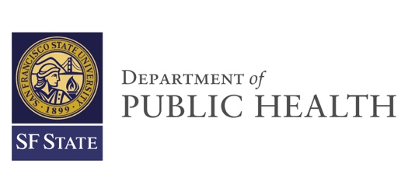
Signature __________________________________
Date __________________________________
Print Full Name __________________________________

