**SAN FRANCISCO STATE UNIVERSITY**

**DEPARTMENT OF PUBLIC HEALTH**



**MASTER OF PUBLIC HEALTH**

**PROGRAM REQUIREMENTS CONTRACT (FOR FALL ADMISSION)**

***Review, sign, date, and upload this contract with your SF State MPH program application materials.***

In scheduling class/activity days and times, the SF State Master of Public Health Program does its best to balance sound pedagogy and the needs of working professionals. Participation in the program requires the following commitments from all students:

1. Coursework concentrated as much as possible in one in-person day per week and Zoom evenings.  
   1. For the in-person day, coursework/activities will commence at 9:30 AM and finish by 4:00 PM. In person day is subject to change.
   2. Evening Zoom courses will start no earlier than 5:00pm and end no later than 8:00pm.
   3. SF State MPH students work frequently in small teams on projects. To complete the required team tasks, these student teams meet at mutually agreeable times, which might include evenings, weekends, and business hours on days other than the primary program day, the latter coming in to play when working on projects that include engagement with the community during daytime business hours. When setting meeting times and assigning team member tasks, student teams attempt to minimize conflicts with the work/outside commitment schedules of individual team members. ***However, students should be aware that occasional work hour flexibility, in addition to primary program day, will likely be necessary during periods of student team project completion.***
2. Typically 2-year (five semester) time to graduation; longer time to completion options also available.
3. Taking courses in sequence as a member of a cohort learning community (*Adjustments may be made on a case-by-case basis with approval by the Graduate Program Coordinator).*
4. If required by the Department of Public Health, completion of courses/tutoring to strengthen academic skills, including writing and inferential statistics skills, before commencement of or during enrollment in the MPH program.
5. Repetition of a course if student does not earn the minimum grade specified by the program to progress to next course in sequence (B or higher in all first semester courses & C or higher in subsequent courses, more details in the *MPH Student Handbook*). Students are only allowed to repeat a course once.
6. For first year entering MPH students, required MPH program orientation events, including an orientation day the Thursday *before* the first week of fall semester classes (subject to change).

*Note: All SF State applicants are admitted with conditionally classified status. After meeting any specialized conditions indicated in the departmental admission recommendation letter, both the Level One and Level Two written English proficiency requirements for graduate students (as specified in the SF State Bulletin and in the MPH Student Handbook), completion of at least two consecutive semesters of coursework of 3.0 or higher grade point average, and demonstration of professional ethics and effective collaborative learning skills, an enrolled student is officially moved from conditionally classified to fully classified status. In addition, in order to continue in the MPH program, a student must make satisfactory progress toward degree completion each semester, including meeting all standards as stipulated by the Department of Public Health.*

**If I am recommended for admission to the San Francisco State University Master of Public Health Program, I agree and am able to meet all program requirements outlined in the “Program Requirements Contract.”**

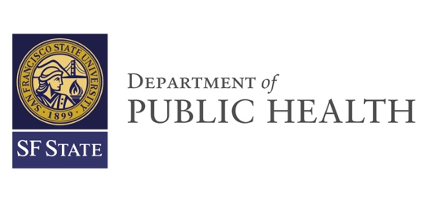Signature __________________________________

Date __________________________________

Print Full Name __________________________________